SALES PERFORMANCE ANALYTICS DASHBOARD
Project Documentation

A Data Analytics Case Study for Cybersecurity Services Sales

Project Overview
The Sales Performance Analytics Dashboard is a data analytics project designed to help management monitor and understand sales performance. The project analyzes sales data across sales representatives, regions, products, and time.
The solution uses Python and Pandas for data cleaning and analysis, and Power BI to create an interactive, professional dashboard. The dashboard helps users identify trends, compare performance, monitor targets, and make better business decisions.

Business Problem
In a cybersecurity services business, management may not have a clear, centralized view of sales performance. It can be difficult to quickly identify which sales representatives, regions, and products are performing well.
This project addresses that gap by creating an interactive Sales Performance Analytics Dashboard that brings together the most important sales insights in one place.

Project Objective
The main objective of this project is to design and build a working Sales Performance Analytics Dashboard that provides clear insight into sales performance. Specifically, the dashboard is intended to:
- Monitor total revenue and overall sales performance.
- Compare performance across sales representatives.
- Analyze regional performance.
- Track revenue trends over time.
- Compare actual sales performance with targets.
- Identify top and bottom performers.

Target Users
Sales Managers — to monitor sales performance and identify areas that need improvement.
Business Analysts — to analyze sales data and identify important trends and patterns.
Management — to view key KPIs and make data-driven business decisions.
Cybersecurity Services Clients — the dashboard structure can be adapted for cybersecurity companies to monitor their own sales and business performance.

Tools and Technologies Used
Tool | Purpose
Python | Data analysis and preparation
Pandas | Data cleaning and analysis
Power BI | Interactive dashboard development
DAX | Creating Power BI measures and calculations
CSV | Source sales dataset
Excel / Google Sheets | Data storage and preparation

Project Workflow
The project followed the workflow below:
Sales Dataset → Python / Pandas → Data Cleaning → Data Analysis → Power BI → Interactive Dashboard → Business Insights
Step 1 — Data Collection: The sales dataset was loaded from a CSV file.
Step 2 — Data Inspection: The dataset was inspected to understand its structure, columns, data types, and quality.
Step 3 — Data Cleaning: The data was checked and prepared for analysis.
Step 4 — Data Analysis: Python and Pandas were used to calculate sales performance metrics.
Step 5 — Dashboard Development: The prepared data was imported into Power BI.
Step 6 — Advanced Features: Target vs. Actual variance and performer ranking were added.
Step 7 — Testing: The dashboard and calculations were tested using filters and a range of scenarios.

Dataset Description
The project uses sample sales data representing sales activity in a cybersecurity services business context. The dataset includes information related to:
- Sales Representative
- Region
- Product
- Revenue
- Sales Date
- Sales Target

Data Cleaning and Preparation
Python and Pandas were used to inspect and prepare the dataset. The following steps were performed:
- Loaded the CSV dataset.
- Reviewed the first rows of the dataset.
- Checked the dataset's column names.
- Checked data types.
- Checked the dataset's shape.
- Reviewed missing or incorrect values.
- Verified categorical columns.
- Prepared the data for analysis.
- Created grouped summaries for key sales metrics.

Python Data Analysis
Python was used to analyze the sales dataset before creating the Power BI dashboard.

Revenue by Sales Representative
Revenue was grouped by sales representative to identify the highest- and lowest-performing representatives. This analysis helps management understand individual sales performance.

Revenue by Region
Revenue was analyzed by region to determine which geographical areas generated the most sales, helping identify strong and weak sales regions.

Revenue by Product
Revenue was grouped by product to identify which products generated the highest revenue, helping the business understand product performance.

Revenue Trend Over Time
Sales revenue was analyzed over time to identify trends and changes in performance, helping management monitor growth or decline in revenue.

Power BI Dashboard
Power BI was used to build the main interactive dashboard. The dashboard brings together key KPIs, charts, rankings, and filters in one place, allowing users to quickly understand sales performance without manually analyzing the raw dataset.

Dashboard Features

KPI Cards
The dashboard includes key KPIs such as Total Revenue, Total Target, Achievement, and Revenue Variance, providing a quick summary of overall sales performance.

Revenue Trend
A line chart displays revenue performance over time, helping users identify sales growth, revenue declines, and performance trends.

Revenue by Sales Representative
A chart compares revenue generated by different sales representatives, helping identify top performers and those who may need additional support.

Revenue by Region
Regional revenue performance is displayed to compare sales across different regions.

Revenue by Product
Product performance is analyzed to identify the products generating the most revenue.

Detailed Sales Table
A detailed table provides additional sales information and allows users to review the underlying performance data.

Interactive Filters and Slicers
The dashboard includes interactive slicers that allow users to filter the data by:

- Region
- Sales Representative
- Product
- Customer Type
- Month

When a user selects a filter, the dashboard's visuals and KPIs update automatically based on the selected data, making the dashboard interactive and easy to use.
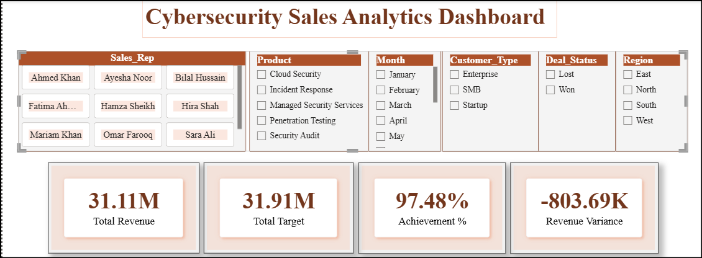
Figure 1. Dashboard overview with KPI cards and slicers
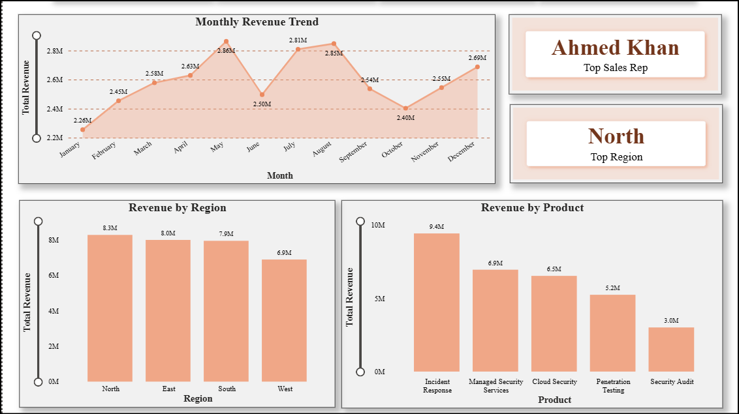
Figure 2. Revenue Trend, regional, and product performance breakdown.
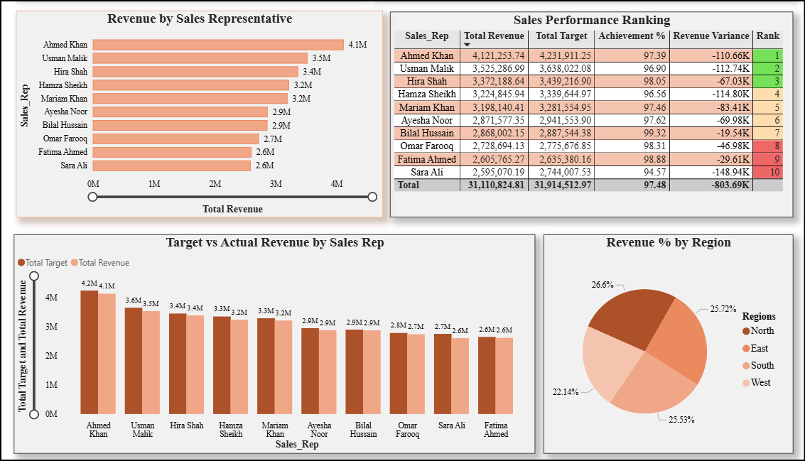
Figure 3. Representative performance and detailed sales table.

Advanced Feature 1: Target vs. Actual Variance
One advanced feature added to the project is Target vs. Actual analysis, which compares actual revenue against the sales target.
Variance = Actual Revenue − Target Revenue
This allows management to quickly determine whether sales performance is above or below the expected target.

Advanced Feature 2: Top and Bottom Performer Ranking
The second advanced feature ranks sales representatives based on their revenue performance. This feature helps management:
- Identify top-performing representatives.
- Identify lower-performing representatives.
- Recognize high-performing employees.
- Identify areas where additional support or training may be required.

Challenges and Solutions
Challenge 1 — Incorrect Column Name: A column name error occurred while analyzing the dataset in Python.
Solution: The dataset's column names were checked using df.columns, and the code was updated to match the correct column name.

Challenge 2 — File Path Error: A file-loading error occurred because Python could not locate the sales dataset.
Solution: The correct file path was identified and used when loading the CSV file.

Challenge 3 — Dashboard Layout: There were many visuals to fit onto a single Power BI page, including KPI cards, charts, slicers, and tables.
Solution: The visuals were organized by importance, with KPI cards at the top followed by the revenue trend and comparison charts. Filters and detailed information were arranged to maintain a clean, professional dashboard layout.

Key Business Questions Answered
- Which sales representative generates the highest revenue?
- Which region performs best?
- Which product generates the most revenue?
- How does revenue change over time?
- Who are the top and bottom sales performers?
- Is actual revenue above or below the sales target?

Key Insights
The dashboard provides important insights into sales performance, including:
- Identification of top-performing sales representatives.
- Comparison of revenue across different regions.
- Identification of high-performing products.
- Analysis of sales trends over time.
- Identification of performance gaps between actual revenue and targets.

Testing and Validation
The dashboard was tested to confirm that its calculations, visuals, and interactive filters worked correctly:
- Checked that KPI cards display correct values.
- Tested the Region slicer.
- Tested the Sales Representative slicer.
- Tested the Product slicer.
- Tested the Customer Type slicer.
- Tested the Month slicer.
- Checked that visuals update correctly when filters are applied.
- Verified the Top and Bottom Performer ranking.
- Verified the Target vs. Actual variance calculation.
- Checked that clearing filters returns the dashboard to the overall view.

SafeX Use Case
This dashboard can be adapted for SafeX's internal sales reporting or offered as a solution to cybersecurity services clients. In a live business environment, it could be connected to real-time sales data, CRM systems, Excel files, or databases.
Management could use the dashboard to monitor revenue, sales targets, employee performance, regional performance, product performance, and sales trends.

Skills Learned
During this project, the following skills were developed and strengthened:
- Data cleaning using Pandas.
- Data analysis using Python.
- Grouping and aggregating data.
- Creating business KPIs.
- Building interactive Power BI dashboards.
- Creating DAX measures.
- Designing charts and visuals.
- Data storytelling.
- Dashboard layout and organization.
- Testing data calculations.
- Troubleshooting technical errors.
- Turning a business problem into a working data solution.

Conclusion
The Sales Performance Analytics Dashboard successfully transforms raw sales data into meaningful business insights. The project uses Python and Pandas for data analysis and Power BI for interactive visualization, allowing management to monitor sales performance, identify trends, compare sales representatives and regions, analyze product performance, and measure performance against targets.
The project demonstrates an end-to-end data science and business analytics workflow:
Raw Data → Data Cleaning → Python Analysis → Power BI Dashboard → Business Insights → Better Decision-Making
This project also demonstrates practical skills in data analysis, dashboard development, problem-solving, and data storytelling, making it a strong portfolio project for a Data Science career.

